Networking Challenge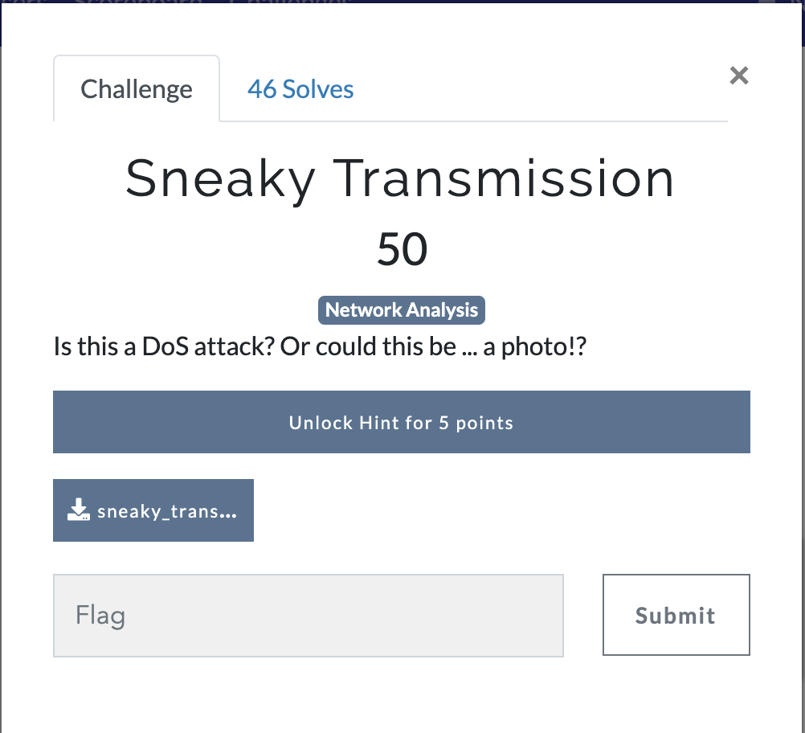
Answer: We’re given a PCAP lets open it up.
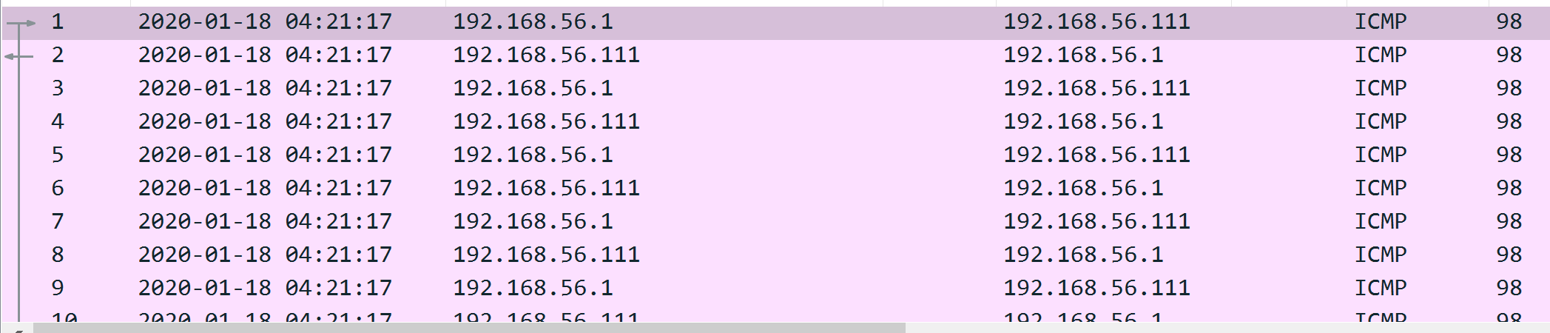
Looks like all ICMP traffic. Looking at frame 9 we see something strange.
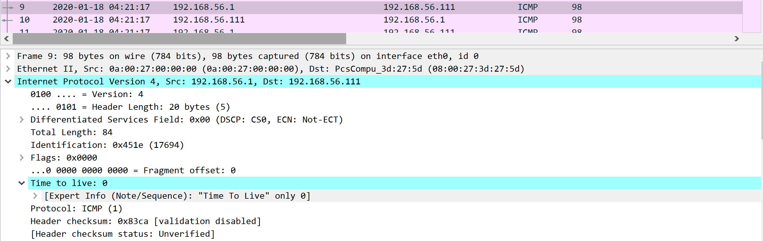
Why is the ttl 0. Looking at some of the other ICMP request it looks like the ttl is different for all. Let’s extract these values and see what we get.
WE’ll use tshark to complete this.
Command: tshark -r sneaky_transmission.pcapng | grep "(ping) request" | cut -d "=" -f4
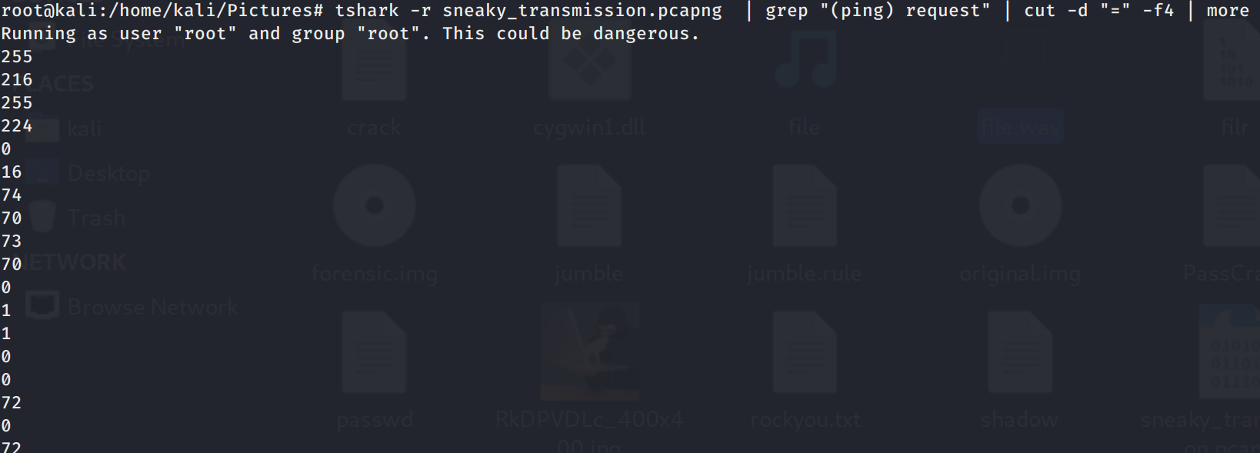
Get the command works, now let’s dump the output into a file.
Command: tshark -r sneaky_transmission.pcapng | grep "(ping) request" | cut -d "=" -f4 > ttl
Looks like we have to convert from decimal, let’s use cyberchef https://gchq.github.io/CyberChef/
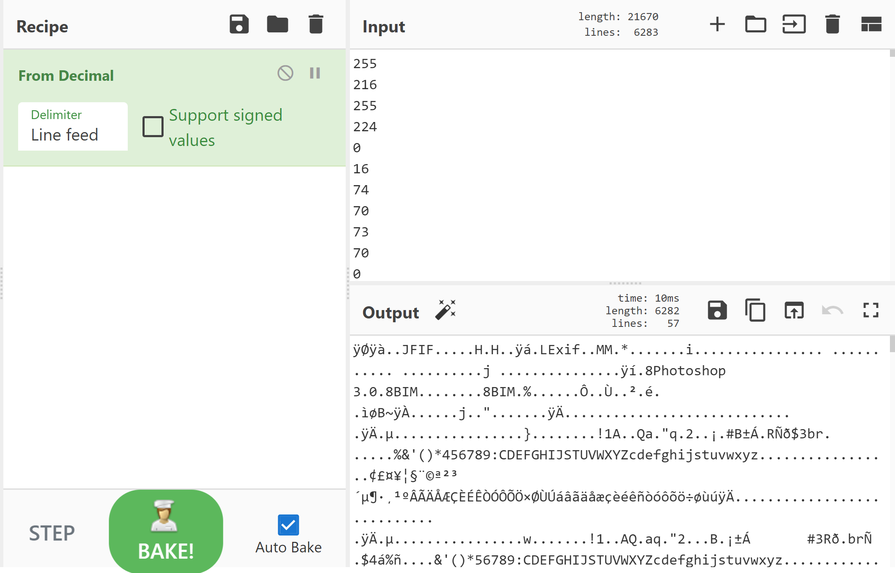
We can see the JFIF tag, good looks like an image lets download and open it up.
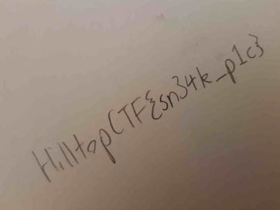
FLAG: HilltopCTF{sn3ek_p1c}
The same can be done in kali with the below command.

